令和６年度

第２回全校テスト

第３学年英語科

2024/09/27

Class：＿＿＿＿＿ No.：＿＿＿＿

Name：＿＿＿＿＿＿＿＿＿＿＿＿＿＿＿

１～４の問題はリスニングテストです。英文はすべて2回繰り返します。

１．（１）～（３）の対話の内容に合う絵を，それぞれのア～ウの中から１つずつ選び，その記号を書きなさい。
（１）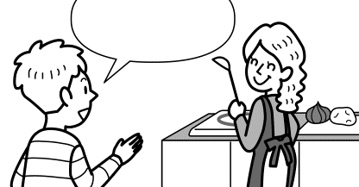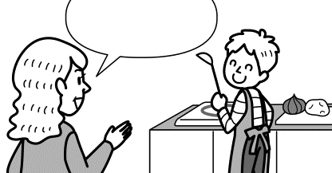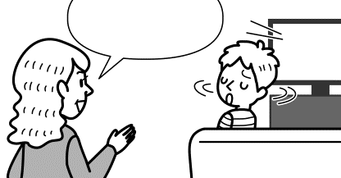（１）

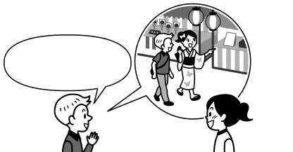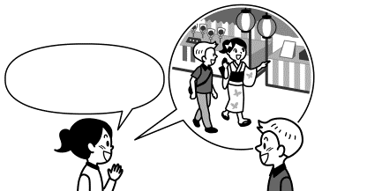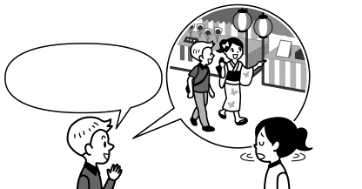（２）
一緒にお祭りに
来て
一緒にお祭りに
来て

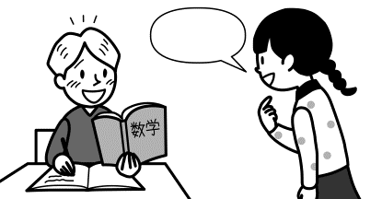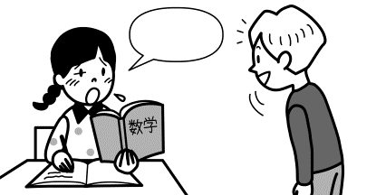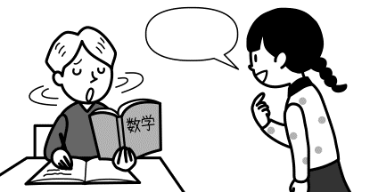（３）
ウ
ア
イ
Emi
Emi
Emi

２．次の英語とその内容に関する質問を聞いて、その質問に対する答えを１つ選んで、記号で書きなさい。
(1)  ア To read English.  イ To speak English.  ウ To write English.  エ To teach English. | (2)  ア Last Monday.  イ Last Tuesday.  ウ Last Wednesday.  エ Last Thursday. | (3)  ア For two months.  イ For six months.  ウ For a year.  エ For five years. | (4)  ア How to go to Tokyo.  イ How to go to the station.  ウ How to buy a ticket.  エ How to meet his friend.

3．留学生のリリーのスピーチの英文を聞いて，その内容に合うように，次の（１）～（３）のそれぞれの（ ）内に適する日本語を書きなさい。

（１）リリーの両親はずっとリリーに（ ）してほしかったので喜びました。
（２）リリーは妹とよく（ ）ので，妹はリリーに日本へ行ってほしくありませんでした。
（３）リリーは，自分が日本にいるときは（ ）ように妹に言いました。

４．アメリカの姉妹校に通うDavidから動画が送られてきました。動画の音声を聞いて(1)～(4)の英文の質問に対し，最も適切なものを一つ選び，その記号を書きなさい。
(1) | ア． Japanese culture. | イ． Japanese history. | ウ．Japanese cooking.
(2) | ア． For two years. | イ． For five years. | ウ． For three years.
(3) | ア． Twenty. | イ．Thirty. | ウ．Forty.
(4) | ア．To have lunch. | イ． To sleep. | ウ． To finish their homework.

リスニングテストは以上でおしまいです。答えは解答用紙に記入してください。
５．次の（ ）の中の語を適当な形に直しなさい。直す必要がない場合はそのまま書きなさい。
(1) People helped Toki ( live ) safely. ※Toki : トキ（鳥）
(2) My cat is ( big ) than your dog.
(3) She was very good at ( cook ).
(4) ( live ) in Akita was exciting for me.
(5) I have already ( read ) the book.

６．次の英文は，英語俳句の特徴をまとめた英文です。メモをもとに英文の①～⑤に入る適切な英語を，１語または２語で書きなさい。ただし，文頭に来る語は，最初の文字を大文字にすること。
・外国人は長年ずっと書き続けている
・短くて書くのが簡単なので人気がある
・日本の俳句よりルールが厳しくない
・季語は不必要
・音節を数える必要もない
Haiku in English
People outside Japan have been ①（ ） their own haiku for many years. Haiku in English have become quite ②（ ） because they’re short and easy to write. The rules for English haiku are less ③（ ）than the Japanese rules. For example, a seasonal word is not always ④（ ）. It’s not always ④（ ）to count syllables, ⑤（ ）. ※ ④は2カ所あります。

記事を読んだときにとったメモ

７．（ ）内の語を並びかえて、日本文にあう英文を書きなさい。問題の作成上小文字にしてある部分があるが、大文字にするべきところは大文字で書きなさい。

- ( for / important / it / us / to / is / help ) each other. | 私たちにとって互いに助け合うことは重要です。
(2) ( myself / me / introduce / let ) first. | 最初に自己紹介をさせてください。
(3) ( a doctor / my father / me / be / wanted / to ). | 父は私に医者になってほしかった。
(4) ( the book / you / yet / bought / have ) ? | あなたはもうその本を買いましたか。
- ( have / waiting for / how / you / been / long /him )? | 君はどれくらい長く彼を待っているのですか。

８. (1)～(4)の英文を読んで,あとの問いに答えなさい。
- シカ(deer)の数の変化とその影響について書かれた記事です。下の図は英文の内容を図式化したものです。
下線部にそれぞれ適切な英語１語を英文中から抜き出し，図を完成させなさい。下線部は5カ所あります。
Japan’s Deer Problems
The large number of deer in Japan is causing trouble. The number has been decreasing since 2014, but there are still problems.
Deer eat a lot of plants and sometimes do serious damage to forests. The forests may disappear. Without forests, there are more landslides when it rains. This also affects other living things. Some kinds of birds and insects have disappeared because they lost their homes. Deer are now seen in towns and cities to find their food, and they may cause traffic accidents. Japan must make efforts to solve these problems.
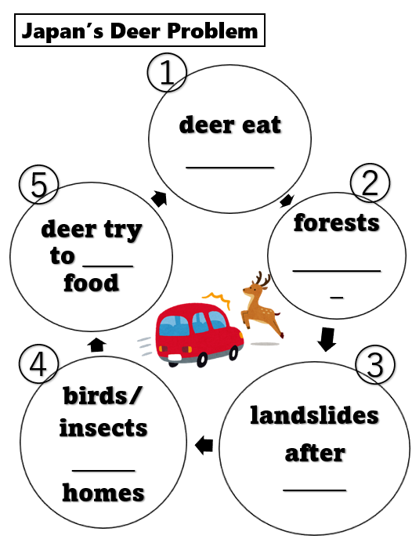

(2) 次の，由紀が書いた手紙の英文を読んで，あとの問いに答えなさい。
March 26, 2025
Dear Ms. Green,
How are you? I’m in Florida now! My parents and I were invited by Mr. Smith during the spring vacation. He is my father’s friend. My father studied in Florida for two years when he was a student. I’m excited because this is my first trip abroad.
Yesterday Mr. Smith took us to a lake. When we got there, some people were swimming in the lake. My father said, “It’s always hot or warm here, so people can swim even in winter.” ①My mother and I were surprised to hear that. We didn’t swim, but we enjoyed riding a boat. I saw a lot of manatees from the boat. Mr. Smith said, “Manatees usually stay in Florida from November to March. They are loved by many people here.” I took a lot of pictures of manatees. They were really cute.
Today we went shopping at a supermarket near Mr. Smith’s house. A lot of items of manatees were
②( ) there. I bought some cards with pictures of manatees for my friends. I also bought you a nice cup. It has a picture of manatees on it. I hope you like it.
See you soon,
Yuki
〈注〉 Florida フロリダ（州名） invite 招待する warm 暖かい manatee マナティ（生物名） item 品物

❶次の質問に主語と動詞のある英文で答えなさい。 Who is Mr. Smith?
❷下線部①にあるthatは具体的にどういうことですか。答えは日本語で答えなさい。
❸②の（ ）には文脈から考えて適切だと思う英語１語を書きなさい。

- Takuyaは，ホストファミリーのBillからホームステイの説明を受けているところです。その内容について①②③の質問をします。質問の答えは主語と動詞のある英文になるように下線部に1語ずつ単語が書きなさい。

Hi, Takuya. I live with my mother, father, and three cats. There are five rooms in our house. Your room is next to my room. We usually eat breakfast at six thirty a.m. and dinner at seven p.m. My father works at home, so he cooks for us every day. Wen you will not eat dinner at home, you have to send an e-mail to my father. We usually have some free time after dinner. I often play video games. Let’s do it together.

- How many cats are there in Bill’s house? ---- ___________ _________ ___________ cats.
- What time does Bill’s family usually eat dinner? ---- They usually ______ _____ at _________ _____.
- Who cooks every day? ---- _____________ _____________ __________.

- 次の英文はヒナとトムの対話です。読んで❶❷の問いに答えなさい。
Hina: Last week, your father made me some cookies. He looked *proud and said, “Please enjoy them.” They were sweet and delicious.
Tom: The next week, your mother made me a cake for us. It was sweet and delicious, and it looks so *lovely! But she said, “I'm sorry that this cake doesn’t look nice.” Why did she apologize?
Hina: Because Japanese people think that it is important to be modest. Being modest is good. But being too modest can become *negative.
Tom: Exactly. After we work hard or doing something nice, we should enjoy the *compliment. I think everyone should be more ( p ).

【注】proud 誇りに思う lovely かわいらしい negative 悲観的な，否定的な compliment ほめ言葉

❶文中の下線部modestの意味として適切なものをア～エの中から選びその記号を書きなさい。
    - 傲慢な イ．横柄な ウ．謙虚な エ．上品な
❷（ ）の中に入るpから始まる英語1語を文脈から判断して書きなさい。

９．(1)～(4)の場面の表現として適切な表現を下線部に書きなさい。※（ ）の中の内容になるように
(1) 海斗とメグが話している場面
Kaito: ① _______ ________ we write an article for our class newspaper? (提案をしている)
Meg: That’s a good idea.

(2) 山中に初めてやってきたYaron 先生と仁先生が話している場面
Mr. Jin : I have ② _______ ________ forward to _________ you. (会うのをずっと楽しみにしていた)
Mr. Yaron: Me, too.

(3) 大高先生とYaron先生が話している場面
Ms. Otaka: ③ __________ you __________ ___________ “Junsai”? (ジュンサイ食べたことある？)
Mr. Yaron : No, I haven’t. But what is “Junsai”?
Ms. Otaka: It is a famous product in Mitane. It’s delicious and easy to cook.
④ I’ll ________ you ________ _____ _________ it. (料理の仕方を教えてあげるよ。)

(4) 福司先生とYaron先生が話している場面
Mr. Yaron: Are those yours? ⑤ Let __________ __________ your pictures.
Mr. Fukushi : OK. I’ll show you. They are my family.
Mr. Yaron: How cute!

10．次の英文は，ある新聞の記事に対する投稿文です。投稿文の内容に対し，賛成か反対のどちらかを選んで，あなた自身の考えを理由を付け加えて書きなさい。答えは15語以上の英文で書きなさい。英文の数は問わない。
I know *walking and texting is sometimes dangerous. However, I do not think we need laws for electronic device use on the street. I have two reasons.
First, sometimes we really need to use those devices outside. If you are looking at a map, it is a *bother to stop looking when you cross the street.
Second, we can make our own decisions. Bike *accidents are common, but many people choose to ride them anyway.
We cannot *ban everything. I do not think we need such a law.
【注】walking and texting 歩きスマホ bother 面倒 accident 事故 ban ～を禁止にする

解答用紙 Class: _______ No.: _______ Name: _________________________________________ Points: _________
1.  2点 | (1) | (2) |  | (3)
2.  2点 | (1) | (2) |  | (3) |  | (4)
3.  2点 | (1) |  | (2) |  | (3) |  | 思考･判断  /28
4.  2点 | (1) | (2) |  | (3) |  | (4)
5.  2点 | (1) |  | (2) |  | (3)
 | (4) |  | (5)
6.  2点 | (1) |  | (2) |  | (3)
 | (4) |  | (5)
7.  2点 | (1)  each other.
(2)
first.
(3)
.
 | (4)  ? |  |  |  |  |  | 知識･技能  /30
(5)
?
8.  (1)各1点  (2)各  3点  (3)各３点  (4)各２点 | (1)① |  | (1)② |  | (1)③
 | (1)④ |  | (1)⑤
 | (2)❶
 | (2)❷
 | (2)❸
(3)①
__________________ __________________ __________________ cats.
(3)②
They usually __________________ __________________ at__________________ __________________.
 | (3)③  __________________ __________________ __________________. |  |  |  |  |  | 思考･判断  /27
 | (4)❶ |  | (4)❷
9.  2点 | - ___________ _____________ we write an article for our class newspaper?
 | - I have __________ ________________ forward to _________________ you.
 | - ___________ you ____________ ______________ “Junsai”?
 | - I’ll ____________ you ___________ _________ ______________ it.
 | - Let ___________ ___________ your pictures.
10.
5点
思考･表現

/15
リスニングテスト原稿
１～４の問題はリスニングテストです。英文はすべて2回繰り返します。

１．（１）～（３）の対話の内容に合う絵を，それぞれのア～ウの中から１つずつ選び，その記号を書きなさい。
（１）（１）
MomMom
アア
イイ
ウウ
夕食を作って

夕食を作って

Mom
Mom

Mom
Mom

Alex
Alex

AlexAlex
Alex
Alex

夕食を作って

夕食を作って

夕食を作って

夕食を作って

（２）
RikaRika
一緒にお祭りに
来て一緒にお祭りに
来て
アア
イイ
ウウ
RikaRika
RikaRika
Henry
Henry

HenryHenry
HenryHenry
一緒にお祭りに
来て
一緒にお祭りに
来て

（３）
イイ
アア
ウウ
手伝うよ

手伝うよ

手伝うよ

手伝うよ

手伝って

手伝って

Tom
Tom

Tom
Tom

Tom
Tom

ウ
ア
イ
Emi
Emi
Emi

【Track ９】
１ （１）～（３）の対話を聞いて，その内容に合う絵を，それぞれのア～ウの中から１つずつ選び，その記号を書きなさい。対話は，２回ずつくり返します。

【Track １０】
（１） A: Mom, where is Alex?
B: He is in the kitchen. I asked him to cook dinner.
（２） A: Rika, I want you to come to the festival with me tomorrow. Can you come?
B: Of course, Henry.
（３） A: Tom, I’ll help you do your math homework.
B: Really? Thanks, Emi!

解答：（１）イ （２）ウ （３）ア

２．次の英語とその内容に関する質問を聞いて、その質問に対する答えを１つ選んで、記号で書きなさい。
(1)  ア To read English.  イ To speak English.  ウ To write English.  エ To teach English. | (2)  ア Last Monday.  イ Last Tuesday.  ウ Last Wednesday.  エ Last Thursday. | (3)  ア For two months.  イ For six months.  ウ For a year.  エ For five years. | (4)  ア How to go to Tokyo.  イ How to go to the station.  ウ How to buy a ticket.  エ How to meet his friend.

［放送台本］
(1) ＜トラック４５＞
Kumi is in the English club. She likes reading English, but it’s difficult for her to speak it. She wants to study in Canada some day, so she is practicing speaking hard.
Question: What is difficult for Kumi? （×２）
(2) ＜トラック４９＞
Mayumi likes reading books. She’s in the book club. The club members meet at the library every Monday and Wednesday. Last Monday they started writing a school newspaper. They want many students to read it.
Question: When did the book club start writing a school newspaper? （×２）
(3) ＜トラック２１＞
F: How long have you stayed in Japan, Mr. Brown?
M: I’ve been here for six months, but this is my second stay in Japan.
F: Really?
M: I came to Japan five years ago and stayed for a year. I was a student then.
Question: How long has Mr. Brown been in Japan this time? （×２）
(4) ＜トラック４２＞
F: What are you going to do for your summer vacation?
M: I’m going to meet my friend in Tokyo.
F: That sounds nice. How will you go there?
M: I want to take the shinkansen. Can you tell me how to buy a shinkansen ticket to Tokyo?
F: Sure.
Question: What does the boy want to know? （×２）

3．留学生のリリーのスピーチの英文を聞いて，その内容に合うように，次の（１）～（３）のそれぞれの（ ）内に適する日本語を書きなさい。
（１）リリーの両親はずっとリリーに（ ）してほしかったので喜びました。

（２）リリーは妹とよく（ ）ので，妹はリリーに日本へ行ってほしくありませんでした。

（３）リリーは，自分が日本にいるときは（ ）ように妹に言いました。

【Track １１】
２ 留学生のリリーのスピーチの英文を聞いて，その内容に合うように，次の（１）～（３）のそれぞれの（ ）内に適する日本語を書きなさい。英文は，２回くり返します。では，始めます。

【Track １２】
Hello, I’m Lily. Today, I want to tell you about my family in Australia. One day at dinner, I said to my family, “I want to go to Japan to study.” My parents said they would let me go. They always wanted me to study abroad. So they were happy, but my sister was sad to hear that. She didn’t want me to go to Japan because I often played with her. I said, “Don’t worry, I will go there for only one year.” I told her to help our mother and father when I am in Japan. Now she often calls me, and we talk a lot. Thank you.

解答：（１）外国で勉強[留学] （２）一緒に遊んでいた （３）母と父を手伝う[助ける]
４．アメリカの姉妹校に通うDavidから動画が送られてきました。動画の音声を聞いて(1)～(4)の英文の質問に対し，最も適切なものを一つ選び，その記号を書きなさい。
(1) ア． Japanese culture. イ． Japanese history. ウ．Japanese cooking.

(2) ア． For two years. イ． For five years. ウ． For three years.

(3) ア． Twenty. イ．Thirty. ウ．Forty.

(4) ア．To have lunch. イ． To sleep. ウ． To finish their homework.

Script
Hello, I'm David. I'm interested in Japanese history and I have been studying Japanese for three years. Today I will show you our school.
First, let's go to our gym. Our school has many different kinds of after school activities. One of them is the dance club. The dance club has twenty members. The members have been practicing for three hours because they have an important contest this week.
Next is our school library. Many students spend time at the library after school to study and finish their homework.
I often talk with Ms. Hill here. She has been working as a volunteer at our library since 1990.
If you can, please tell me about your school, too.

(1) What is David interested in?
ア． Japanese culture. イ． Japanese history. ウ．Japanese cooking.

(2) How long has David been studying Japanese?
ア． For two years. イ． For five years. ウ． For three years.

(3) How many members are there in the dance club?
ア． Twenty. イ．Thirty. ウ．Forty.

(4) Why do many students go to the library?
ア．To have lunch. イ． To sleep. ウ． To finish their homework.

リスニングテストは以上でおしまいです。答えは解答用紙に記入してください。

*Paris Olympic Games ended last August in 2024. Japan got 45 *medals, and these are the highest ever for Japan at an overseas Olympics.
In 1912，Japan joined the 5th Olympic Games for the first time. At that time, there was no symbol of the Olympic games. In 1914 5rings were started using as the symbol of the games. Each ring has different color: blue, yellow, black, green and red. They mean Europe, Africa, Asia, *Oceania and America. The idea is that “the world is one.” About 10,500 athletes joined the Paris Olympic Game from about 200countries. Not only athletes but also everyone all over the world enjoys the Olympic Games every four years.

